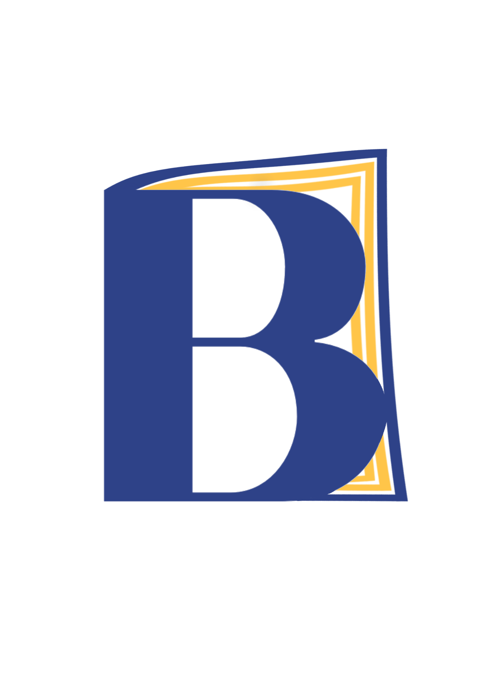 | Resources for Families in Kansas  Recommended by Building Bonds Through Books  In addition to the book provided by BBTB, here are some resources families may find helpful in navigating education in addition to community resources. We have also provided a supplemental reading list that your local librarian may help you find!
1. Play Free at Kansas Children’s Discovery Center  https://kansasdiscovery.org/page-2/play-free/  Telephone: 785-783-8300  With referrals from Topeka Correctional Facility, children of mothers (and sometimes grandmothers) who are incarcerated at TCF can enjoy a day of play-based education with their incarcerated parents. In addition to bonding opportunities, families can make art, participate in science activities, and explore the outdoors! |  |  | Reading List:  Grade Level Pre-K - 3:  Missing Daddy by Mariame Kaba & Bria Royal  - Our Moms (Living with Incarcerated Parents) by Q. Futrell  - Kennedy’s Big Visit by Daphne Brooks  - My Daddy’s in Jail by Anthony Curcio
2. Kansas City, KS Public Library  https://kclibrary.org/kids  https://kclibrary.org/teens  Telephone: 816.701.3400  The KCKPL has programs for kids and youth catered to their age group. Kids can take advantage of homework help and fun, and join a digital reading room. Teens also have homework help, as well as test prep, and preparation for their driver’s permit test. |  |  | Grade Level 4+:  - Amber Was Brave, Essie Was Smart by Vera B Williams  - Jakeman by Deborah Ellis  - An Inmate’s Daughter by Jan Walker  Grade Level 6+:  - All I Ever Wanted...Stories of Children of the Incarcerated by Erika Duncan, Tanasha Y. Gordon  Parents/Guardians:  - Children with Incarcerated Mothers Separation, Loss, and Reunification by Julie Poehlmann-Tynan, Danielle Dallaire

3. Wichita Public Library (all ages)
https://www.wichitalibrary.org/
Telephone: (316) 261-8500

The WPL offers programs for all youth, and divides them into “Young Readers” ages 0-6 with resources like “1,000 books before kindergarten.” They offer both “Kids” and “Teens” homework help.

Please refer to our National Resources for further assistance!

Contact us at: buildingbondsthroughbooks@gmail.com
Follow us on Instagram and Facebook: @buildingbondsthroughbooks

